CIRCULAR BIOCARBON

City Interest Group Application Form

The City Interest Group will be constituted of 5 to 10 cities or local authorities from all over Europe. It targets primarily cities or urban authorities with an interest in valorising bio-waste, be it the organic fraction of municipal solid waste and sewage sludge, but also rural local governments interested in developing the local bioeconomy in connection with the primary sector. The City Interest Group will closely follow developments within the project and learn from the CIRCULAR BIOCARBON approach and the technical expertise of consortium partners to replicate the process and the results. More specifically, cities will benefit from:

Study Visits
4 study visits will be organised for the City Interest Group in the course of this project, respectively to the urban waste facility run by URBASER / SOCAMEX in Zaragoza (ES), to the productive fields run by AII-RG in Saint-Malo (FR) and 2 to the CAP facilities in Sesto San Giovanni (IT). The study visits will provide ample opportunity for cities to present their status and ambitions to benefit from the experience of project partners.

Replication and training workshops
During the project, two (2) full-day replication and training workshops will take place across Europe. These workshops will aim to consolidate the tools and knowledge needed by the City Interest Group members to pursue replication of the project approach. Each workshop will address a different technical theme related to replication challenges – which can very well be identified in conjunction with the requests of the cities following prior consultation.

City Match Exchanges
Over the course of the project, two (2) City Match Exchange events will take place. City Match Exchanges are hosted by cities that are advanced in the valorisation of urban waste, as a means of one-on-one staff exchange that allows for in-depth discussion and learning.

CIRCULAR BIOCARBON Webinars
A series of webinars on various topics related to biowaste valorisation will be organised in collaboration with project partners to engage cities in the CIRCULAR BIOCARBON replication and exchange network.

To apply to become a member of the City Interest Group, please complete the following information and send this form signed to Simon GRESSET (ICLEI Local Governments for Sustainability) simon.gresset@iclei.org. Please also get in touch if you have any questions.

- Applicant Details
Please provide the following information about your organisation
Official name
Name in English
Region
Country
Website

- Nominated Contact
Please designate a person in your organisation to serve as the primary contact
Name
Title/function
Department
Address
E-mail

- WASTE AND WASTEWATER MANAGEMENT IN YOUR LOCAL AUTHORITY
Is your local authority directly in charge of waste and wastewater management?

If not, please provide information on the entity/entities in charge of waste and wastewater management and on its links with your local authority (e.g. ownership, subcontractor, etc.).

Is this/these entity/entities also carrying out bio-waste valorisation activities (for both municipal solid waste and wastewater? If so, please provide details.

If not, please briefly describe how biowaste from your local authority is valorised.

dli
- INVOLVEMENT IN THE CITY INTEREST GROUP

Which relevant activities is your local government currently undertaking in the field of circular economy? More particularly for the bio-waste streams (i.e. organic fraction of municipal solid waste and sewage sludge)? Are you or the entities in charge of waste and wastewater management involved in any projects or networks on that topic (European, national or regional)?

Which relevant activities is your local government currently undertaking in the field of bioeconomy? Are you involved in any projects or networks on that topic (European, national or regional)?

Why are you interested in becoming a member of the City Interest Group and what are you looking to achieve in your city?
Which of the CIRCULAR BIOCARBON topic areas are you interested in? Please indicate in the overview below and specify in the comments section if necessary
New valorisation routes for bio-waste | Check if Interested
Design of new procedures and techniques for converging with biorefinery models
Production of intermediate products
Production of added-value bio-based materials
Production of marketable, end consumer products
Comments:

- Requirements and Signature

We hereby apply as CIRCULAR BIOCARBON City Interested Group member and commit to delivering the following requirements of the project:
- Attending at least two CIRCULAR BIOCARBON study visits.
- Participation in the Replication and training workshops.
- Participation in the City Match Exchanges.
- Participation in at least two CIRCULAR BIOCARBON webinars.
- Providing an annual update on replication activities for the duration of the project.

The CIRCULAR BIOCARBON has strict protocols relating to confidentiality and media activity, therefore it will be required from City Interest Group members to sign a non-disclosure agreement.

_____________________________ _____________________________
Location, Date Signature

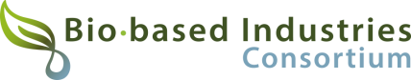
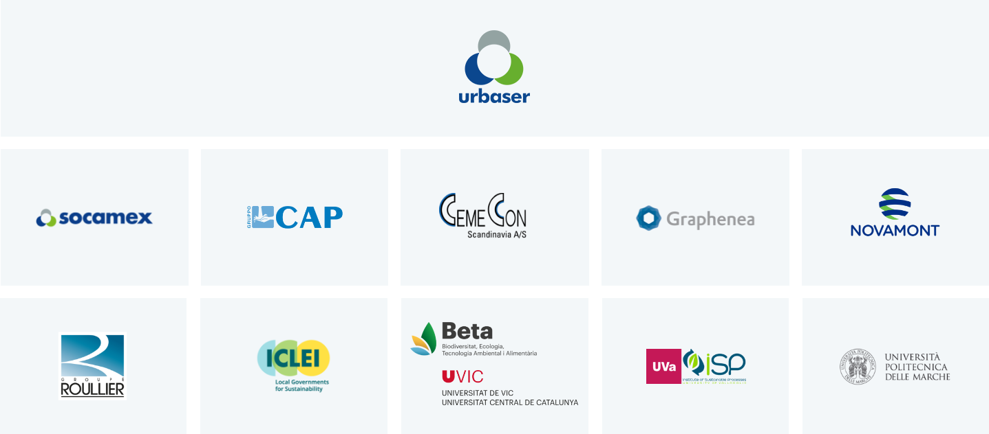
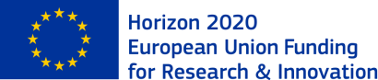

This project has received funding from the Bio-based Industries Joint Undertaking (JU) under the European Union’s Horizon 2020 research and innovation programme under grant agreement No 101023280. The JU receives support from the European Union’s Horizon 2020 research and innovation programme and the Bio-based Industries Consortium.

